Synopsis

Predictive Analytics for Urban Water Demand

Problem Id: 06
Swastik Gairola (2028506)
Hardik Raturi(2028424)
Abhay Singh Butola (2028376)
Section: L

- Problem Description:

This problem is about building a simple data-driven system to predict how much water a household uses daily, which helps cities manage water supply more efficiently.
You start by creating a dataset instead of just downloading one. This means collecting or estimating realistic data for factors that affect water usage:
- Household_Size: More people usually means higher water consumption.
- Seasonal_Indices: Water use changes with seasons (e.g., higher in summer).
- Garden_Area: Larger gardens require more water for irrigation.
Since real-world data is often messy, the next step is data cleaning, where you handle missing values, fix inconsistencies, and ensure the dataset is usable.
After that, you apply StandardScaler. This step standardizes all input features so they are on a similar scale. Without this, variables with larger numeric ranges (like garden area) could dominate the model unfairly.
Then, you train a Linear Regression model. This model learns the relationship between the input features and the target variable (Daily_Liters_Used) and uses it to make predictions.
Finally, residual analysis checks how accurate the model is by comparing predicted values with actual ones. It helps you understand errors and improve the model’s performance.

1. Dataset Creation (Data Collection)
In this project, a synthetic dataset was created to simulate real-world household water consumption patterns instead of using a pre-existing dataset.
The dataset includes the following features:
Feature Name | Description | Data Type
Household_Size | Number of people living in the household | Integer
Seasonal_Index | Season indicator (1 = Winter, 2 = Spring, 3 = Summer, 4 = Monsoon) | Categorical (Encoded as Integer)
Garden_Area | Area of the garden (in square units) | Integer
Daily_Liters_Used | Total daily water consumption (Target Variable) | Integer
The dataset was designed based on realistic assumptions:
- Larger households consume more water
- Water usage increases in summer
- Larger garden areas require more irrigation

2. Data Cleaning and Preprocessing
To ensure data quality and reliability, multiple preprocessing steps were applied:
a) Duplicate Removal
Duplicate records were removed to avoid bias:
df = df.drop_duplicates()
b) Handling Invalid Values
Out-of-range values were identified and replaced with NaN using predefined limits:
- Household_Size → 1 to 10
- Seasonal_Index → 1 to 4
- Garden_Area → 0 to 2000
- Daily_Liters_Used → 50 to 5000
c) Missing Value Imputation
Missing values were handled as follows:
- Categorical features → Mode
- Continuous features → Median
This ensures minimal distortion in data distribution.

3. Data Transformation
a) Data Type Conversion
All features were converted into integer format to maintain consistency.
b) Feature Scaling (Min-Max Scaling)
Min-Max Scaling was applied to normalize values between 0 and 1:
$$X_{scaled}=\frac{X-X_{min}}{X_{max}-X_{min}}$$
This was applied to:
- Garden_Area
- Daily_Liters_Used
c) One-Hot Encoding
The categorical feature Seasonal_Index was converted into multiple binary columns:
- Season_1, Season_2, Season_3, Season_4

4. Outlier Detection and Removal
Outliers were detected using the Interquartile Range (IQR) method:
$$IQR=Q3-Q1 \\ LowerBound=Q1-1.5×IQR \\ UpperBound=Q3+1.5×IQR$$
Data points outside this range were removed to improve model performance.

5. Feature Scaling (Standardization)
Before training the model, StandardScaler was applied:
$$Z=\frac{X-μ}{σ}$$
This ensures:
- Mean = 0
- Standard Deviation = 1
It prevents features like Garden_Area from dominating smaller features like Household_Size.

6. Dataset Splitting
The dataset was divided into:
- 80% Training Data
- 20% Testing Data
train_test_split(test_size=0.2, random_state=42)
This allows proper evaluation on unseen data.

7. Model Building (Linear Regression)
A Linear Regression model was used to learn relationships between input features and water usage.
$$y=b_{0}+b_{1}x_{1}+b_{2}x_{2}$$
Where:
- $y$= Daily_Liters_Used
- $x_{1}$= Household_Size
- $x_{2}$= Garden_Area
The model learns coefficients that best fit the data.

8. Model Evaluation
The model performance was evaluated using:
a) R² Score
- Measures how well the model explains variance
- Value obtained: 0.8849 (High accuracy)
b) Mean Squared Error (MSE)
- Measures average squared error
- Value obtained: 4094.19
c) Mean Absolute Error (MAE)
- Measures average absolute error
- Value obtained: 40.65 liters

9. Residual Analysis (Error Analysis)
Residuals were analyzed to check model performance:
a) Actual vs Predicted Plot
- Helps visualize prediction accuracy
- Ideal case: points lie close to diagonal line
b) Residual Distribution Plot
- Checks if errors follow normal distribution
c) Residual Plot
- Ensures no visible pattern in errors
- Confirms model assumptions are satisfied

10. Final Output
- Final dataset size: 9305 rows, 9 columns
- No missing values
- Model achieved strong predictive performance
- Successfully predicts household daily water consumption

┌───────────────┐
│ START │
└───────┬──────┘
↓
┌────────────────────┐
│ Dataset Curation │
│ • Household Size │
│ • Seasonal Index │
│ • Garden Area │
└────────────┬──────┘
↓
┌──────────────────────┐
│ Data Cleaning │
│ • Handle Missing Values │
│ • Remove Duplicates │
│ • Fix Inconsistencies │
│ • Range Validation │
└────────────┬────────┘
↓
┌───────────────────┐
│ Feature Scaling │
│ • Mean = 0 │
│ • Std Dev = 1 │
└───────────────────┘
↓
┌────────────────────┐
│ Model Building │
│ • Train Model │
│ • Learn Relationships │
└────────────┬───────┘
↓
┌────────────────────┐
│ Model Evaluation │
│ • R² Score │
│ • MAE / MSE │
│ • Error Analysis │
└────────────┬──────┘
↓
┌───────────────────┐
│ Prediction Output │
│ • Daily Water Usage │
│ • Resource Planning │
└────────────┬──────┘
↓
┌───────────────┐
│ END │
└───────────────┘│

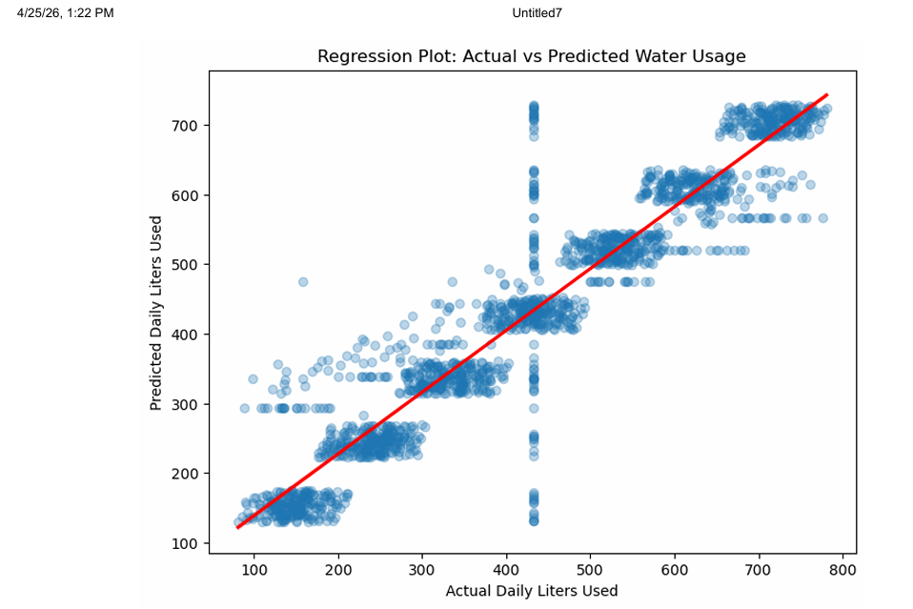

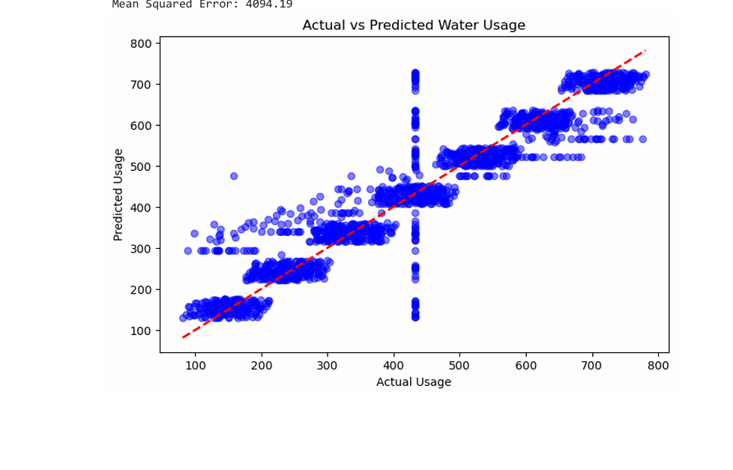

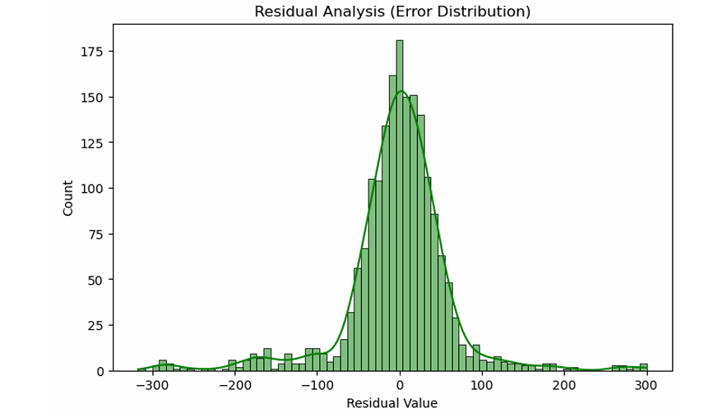
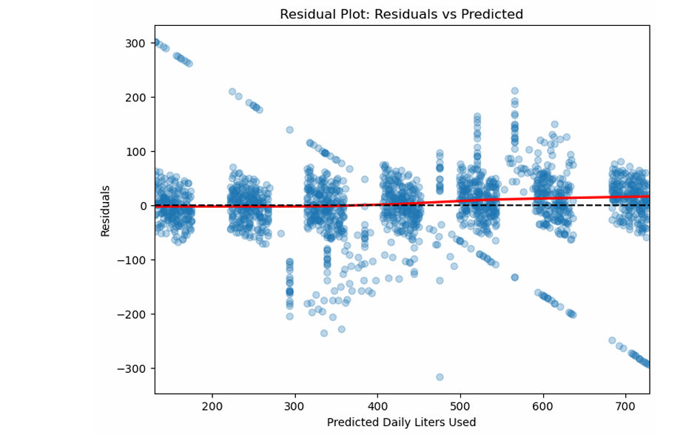

- Expected Modules/ Libraries to be used :
NumPy:
Used for numerical computations and generating synthetic data efficiently. It helps in creating arrays for features like Household_Size, Seasonal_Indices, and Garden_Area, and performing mathematical operations on them.
Pandas:
Used for creating, organizing, and managing the dataset in a tabular DataFrame format. It allows easy handling of missing values, filtering data, and preparing the dataset for model training.
Matplotlib:
Used for visualizing relationships in the dataset. For example, scatter plots can show how water usage varies with household size or garden area, helping in better understanding of data trends.
Scikit-learn:
Provides machine learning tools required for the project, including:
- StandardScaler for feature standardization
- Linear Regression for building the prediction model
- Evaluation metrics for assessing model performance

• Expected Evaluation Metrics and Plots to be used :

Scatter Plot:
Used to visualize the relationship between input features (like Household_Size or Garden_Area) and the target variable (Daily_Liters_Used). It helps in identifying trends and correlations in water consumption.
MAE (Mean Absolute Error):
n​∑i=1n​∣yi​−y^​i​∣
Measures the average absolute difference between predicted and actual water usage. It provides a simple and interpretable measure of prediction accuracy.
MSE (Mean Squared Error):
1/n∑i=1n​(yi​−y^​i​)2
Calculates the average of squared differences between predicted and actual values. It penalizes larger errors more strongly, making it useful for detecting significant prediction mistakes.
R² Score (Coefficient of Determination):
Indicates how well the model explains the variation in water usage data. A value closer to 1 means better model performance.
- → Perfect prediction
- $R^{2}=0$→ Model explains nothing
- $R^{2}<0$→ Poor model
Residual Plot:
Displays the difference between actual and predicted values. It helps check whether errors are randomly distributed, which indicates a good model fit.
Regression Plot:
Shows the relationship between predicted and actual water usage values. A good model will have points closely aligned along a straight line.

- Required topics from the subject:

Data Structures (Arrays & DataFrames):
Arrays and DataFrames are used to store and organize the dataset efficiently. NumPy arrays help in handling numerical data, while Pandas DataFrames make it easier to manage and analyze information such as household size, seasonal index, garden area, and daily water usage.

Functions:
Functions are used to divide the program into smaller, manageable parts. Separate functions can be created for tasks like data collection, preprocessing, scaling using StandardScaler, and training the Linear Regression model.

File Handling:
Used to save and load the dataset (e.g., CSV files) for future use and analysis.

Loops & Conditionals:
Loops are used to process data step by step, such as iterating through dataset entries or performing repeated operations. Conditionals help in making decisions, like handling missing values or applying specific actions based on conditions.

Libraries & Modules:
Various Python libraries are used to simplify the implementation. NumPy and Pandas are used for data handling, Scikit-learn for StandardScaler and Linear Regression, and Matplotlib or Seaborn for visualization and analysis.

- Platform Required:
Jupyter Notebook:
Used as the primary development environment for writing, executing, and interactively visualizing Python code.

Python (Anaconda Distribution):
Provides all required libraries and package management needed for data analysis and machine learning.

- Books and Link Sources:
- https://www.geeksforgeeks.org/ml-linear-regression/
- https://www.geeksforgeeks.org/standardscaler-in-python/
- https://scikit-learn.org/stable/
- https://www.kaggle.com/datasets/prince7489/household-water-consumption-dataset

